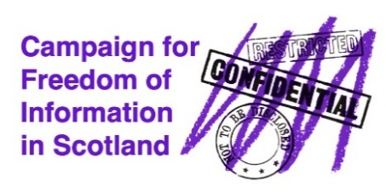
Misinformation
about the Bill
-correcting the record

Legal Reform of FoI Law Overdue
Evidence is mounting for the Freedom of Information (Scotland) Act 2002 (FoISA) to be reformed, for example the detailed inquiry report of the Public Audit and Post Legislative Scrutiny Committee in May 2020. Eventually, five years later, there is an opportunity through the Freedom of Information Reform (Scotland) Bill, introduced by Katy Clark MSP, to deliver transparency by design and strengthen accountability and enable informed scrutiny.

The Stage 1 consultation process on the Bill is now underway, led by the Standards, Procedures and Public Appointments Committee of the Scottish Parliament. It is inviting submissions on the Bill’s general principles by 22nd October. Please consider making a submission as your opinion matters.

Freedom of Information Reform (Scotland) Bill - Misinformation
The Stage 1 consultation process got off to a tricky start as the Committee’s call for evidence contained two factual errors which have now been fixed.
- Erroneously the website stated that the Bill would bring more bodies under freedom of information rules, such housing associations. However RSLs were designated under FoISA in 2019 along with some of their subsidiaries.
- Erroneously the website stated that the Bill would bring third sector organisations under FoISA. That is wrong. The Bill proposes an additional mechanism to enable Parliament to initiate new designations under FoISA. Core to the process is consultation and then a decision is made. Currently the pace of designation is slow because the initiative needs to come from Scottish Ministers.

Additionally how the first bullet point has been worded is being wrongly interpreted by some as the removal of the public interest test when applying an exemption to disclosure. This is not accurate and CFoIS has produced a briefing

What Can You Do?
Please support our campaign by writing to your MSP to ask them to support the Bill and explain the Bill strengthens the outdated FoI law in Scotland by:
- Introducing a new, enforceable duty to pro-actively publish information
- Improving legal compliance by designating an FoI officer in each public body
- Strengthening the enforcement powers of the Scottish Information Commissioner.
Please support the CFoIS all party campaign to ensure the Bill is passed by March 2026.

CFoIS is a SCIO No. SC051263
Published by CFoIS www.cfois.scot/ info@cfois.scot @cfoiscot.bsky.social

Funded by the JRSST Charitable Trust which has supported this work in recognition of the importance of the issue. The facts presented and the views expressed are, however, those of CFoIS and not necessarily those of the Trust.

